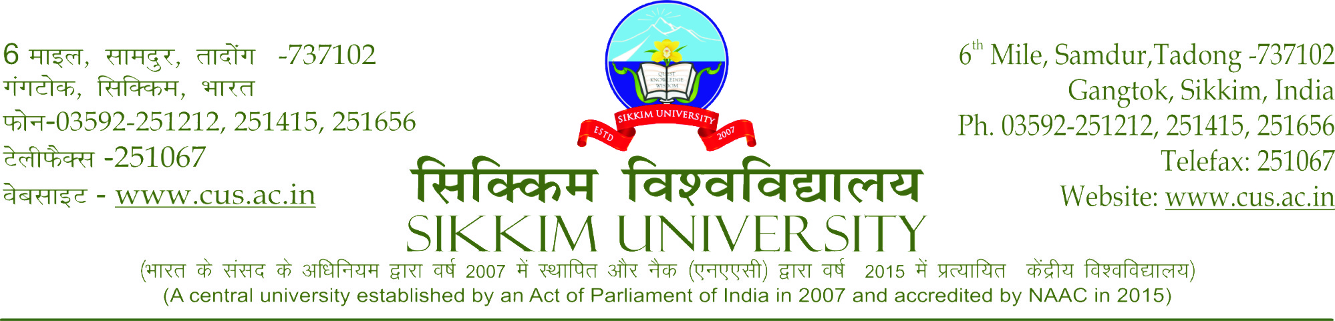
SHORT TENDER NOTICE

Reference No.:SU/REG/ENGG/F3/07/2018/VOL-I(PART-I)/1584 Date:19/12/2018.

Short Tender Notice for Repair and maintenance of online UPS at various location of Sikkim University.

Bids are invited by Sikkim University from eligible and authorized agencies located within Sikkim and Siliguri for the repair and maintenance of online UPS at various location of Sikkim University.
Terms and Conditions

- The products supplied should be of reputed make and model.

- The following documents are to be submitted for the work.
Technical documents:
  - Annexure I (Company Profile and fee details)
  - Company registration certificate.
  - Company PAN Card and GST details
Financial documents:
- BoQ – (Financial Bid in prescribed format)-Annexure II

- The envelope containing the below documents addressed to Executive Engineer, Engineering Cell, Sikkim University, 6th Mile, Samdur, Tadong, Gangtok, Sikkim – 737102 should reach the University on/before 29/12/2018 failing which the participation will stand cancelled:
- Documents listed under 2

- The delivery of goods would be done at the risk and cost of the supplier and all products delivered would be approved only after the examination of the same is done by the Engineering cell of the University.

- The rate should be quoted including all costs such as labour charges, materials, transportation, GST etc. No other charges shall be entertained under any circumstances over and above the cost quoted in the financial bid.

- All support related to service if any should be onsite during the warranty period.

- The supplier should provide the certificate of originality whenever demanded by the University.

- The work should be completed within 15 days of receiving of the work order failing which delay penalty will be charged @ 1% per day on the value of the work order to a maximum of 25% of the work value.

- Payment will be made after successful delivery, installation and the completion of work.

- 5 % performance security shall be deducted from the final bill of the vendor to be release after successful competition of 6 month defect liability period.

- Participating firm may contact Shri. Karma Gyatso Bhutia (Junior Engineer) at mobile phone: 7319083980 for any queries related to the tender.

- Participating firm must quote rate for all the given items, incomplete submission/quotation shall be disqualify.

- Arbitration of all disputes related to the procurement, delivery and service of the goods would be done in the Gangtok jurisdiction, Sikkim.

- The Registrar, Sikkim University, has the power to reject any tender or all tender or extend the date of opening of tender without citing any reasons. Decision of The Registrar, Sikkim University will be final and binding to all tenderers.

Sd/- Registrar

Annexure-I
COMPANY PROFILE
Dated………………………
Notice for Repair and maintenance of online UPS at various location of Sikkim University.
.

FOLLOWING DETAILS ARE TO BE FURNISHED BY THE BIDDING FIRM
- Name of the Firm:
- Address of the Firm:
- Contact no:
- Email address:
- Firm Registration details:
- Permanent Account Number:
- GST registration details:
- Bank Account details including Account Number, Bank name, Branch name & IFSC code:
Declaration:
I/We hereby declare that I/We have read & understood all the terms & conditions mentioned in the tender notice the quotations and I/We undertake myself/ourselves to abide by them.
I/We further, declare that all the information given above is true.

Name:
Designation:
[Official Seal with authorised signature]

Place:

Date:

Annexure II

FINANCIAL BID
in respect to
Notice for Repair and maintenance of online UPS at various location of Sikkim University.

FOLLOWING DETAILS ARE TO BE FURNISHED BY THE BIDDING FIRM

Table 1: Product Make and Model
Sl.No | Description of items | Brand | Qnty | Unit | Quoted Rate | Amount
1 | Repairing of Inverter kit | - | 5 | Nos
2 | Battery 42 Ah, 12 Volt, SMF | Exide or equivalent | 3 | Nos
3 | Repairing of Power driver | - | 1 | Nos
4 | Repairing of Rectifier | - | 1 | Nos
5 | Service charges for installation of the component , test check and all complete as required | - | 10 | per/ups
Total Amount without GST
GST @........%
Total amount inclusive of GST

Name:
Designation:
[Official Seal with authorized signature]
Place:
Date:

